1. [Level Order Traversal - Coding Ninjas](https://www.codingninjas.com/studio/problems/level-order-traversal_796002)

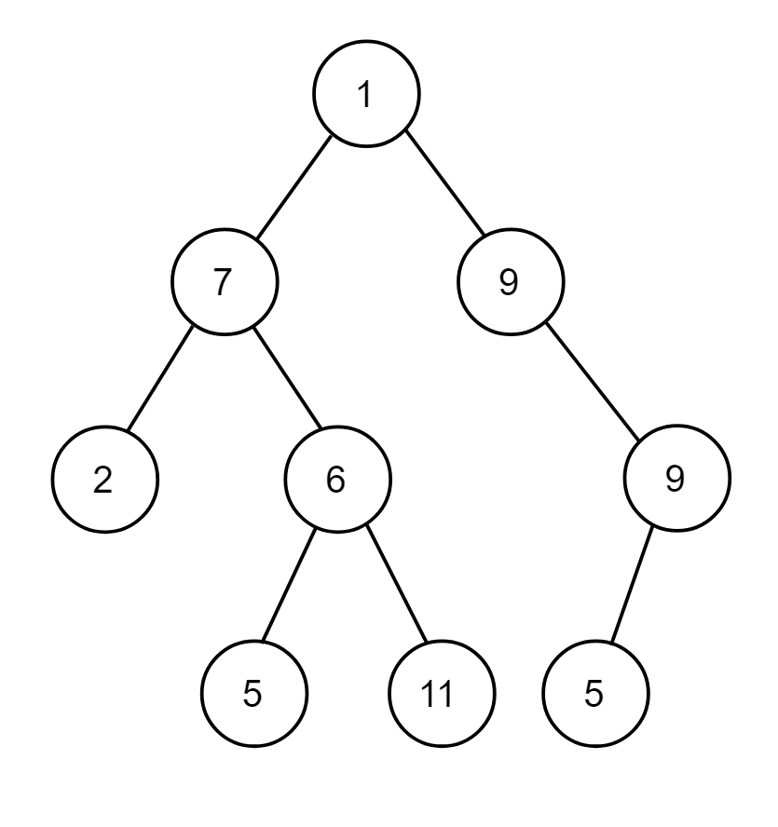

1. What should you write in input.txt in order to input this binary tree?

**2. Answer:**

**1 7 9 2 6 -1 9 -1 -1 5 11 5 -1 -1 -1 -1 -1 -1 -1**